Que 3: Design menu bar that may have sub-menus using HTML lists and styling with CSS . Add hyperlinks of menus to another web page within your HTML document .

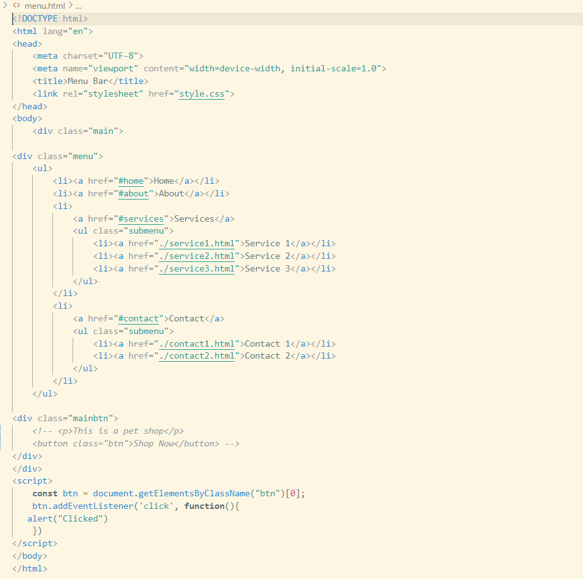

Styling of menu.html (style.css)

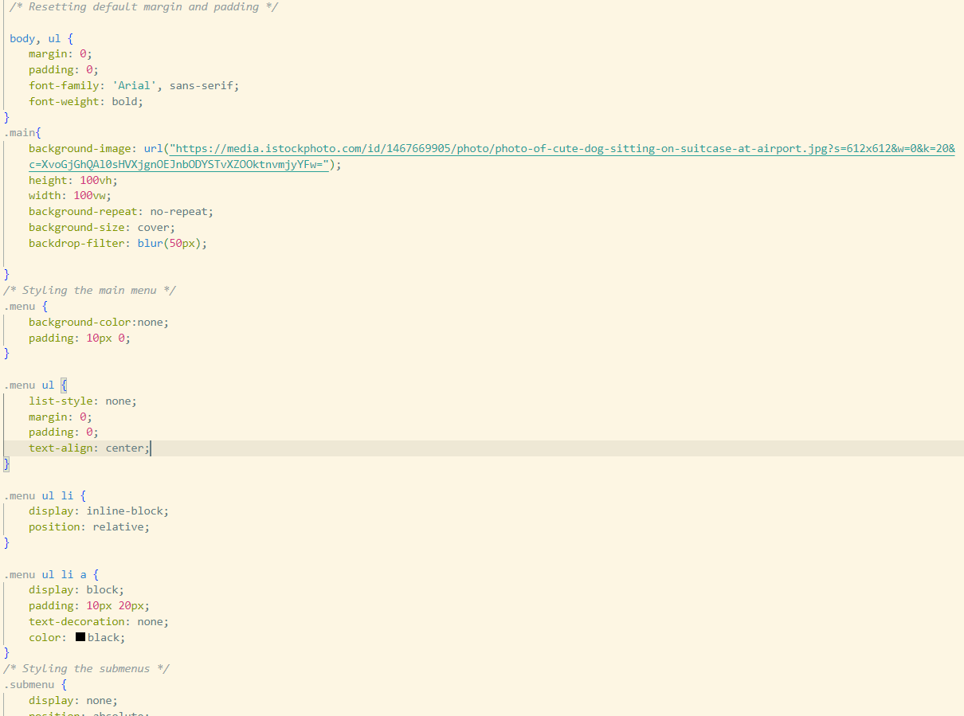

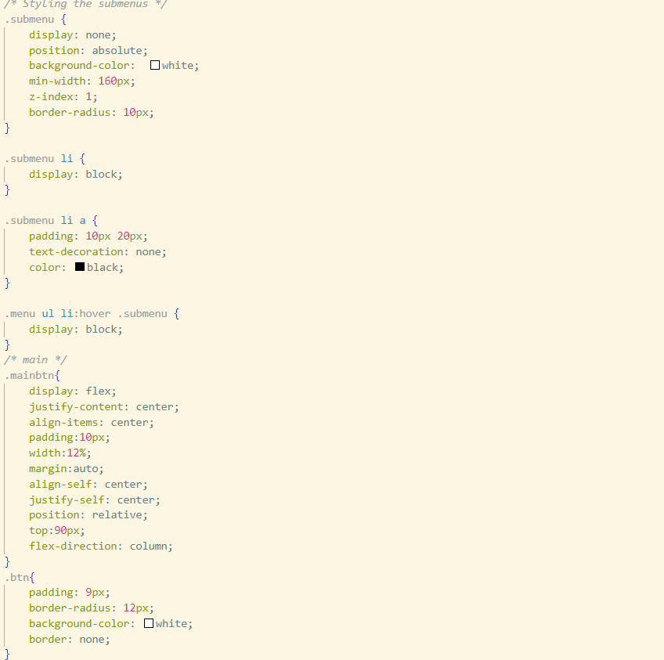

Output of menu bar is as follow :

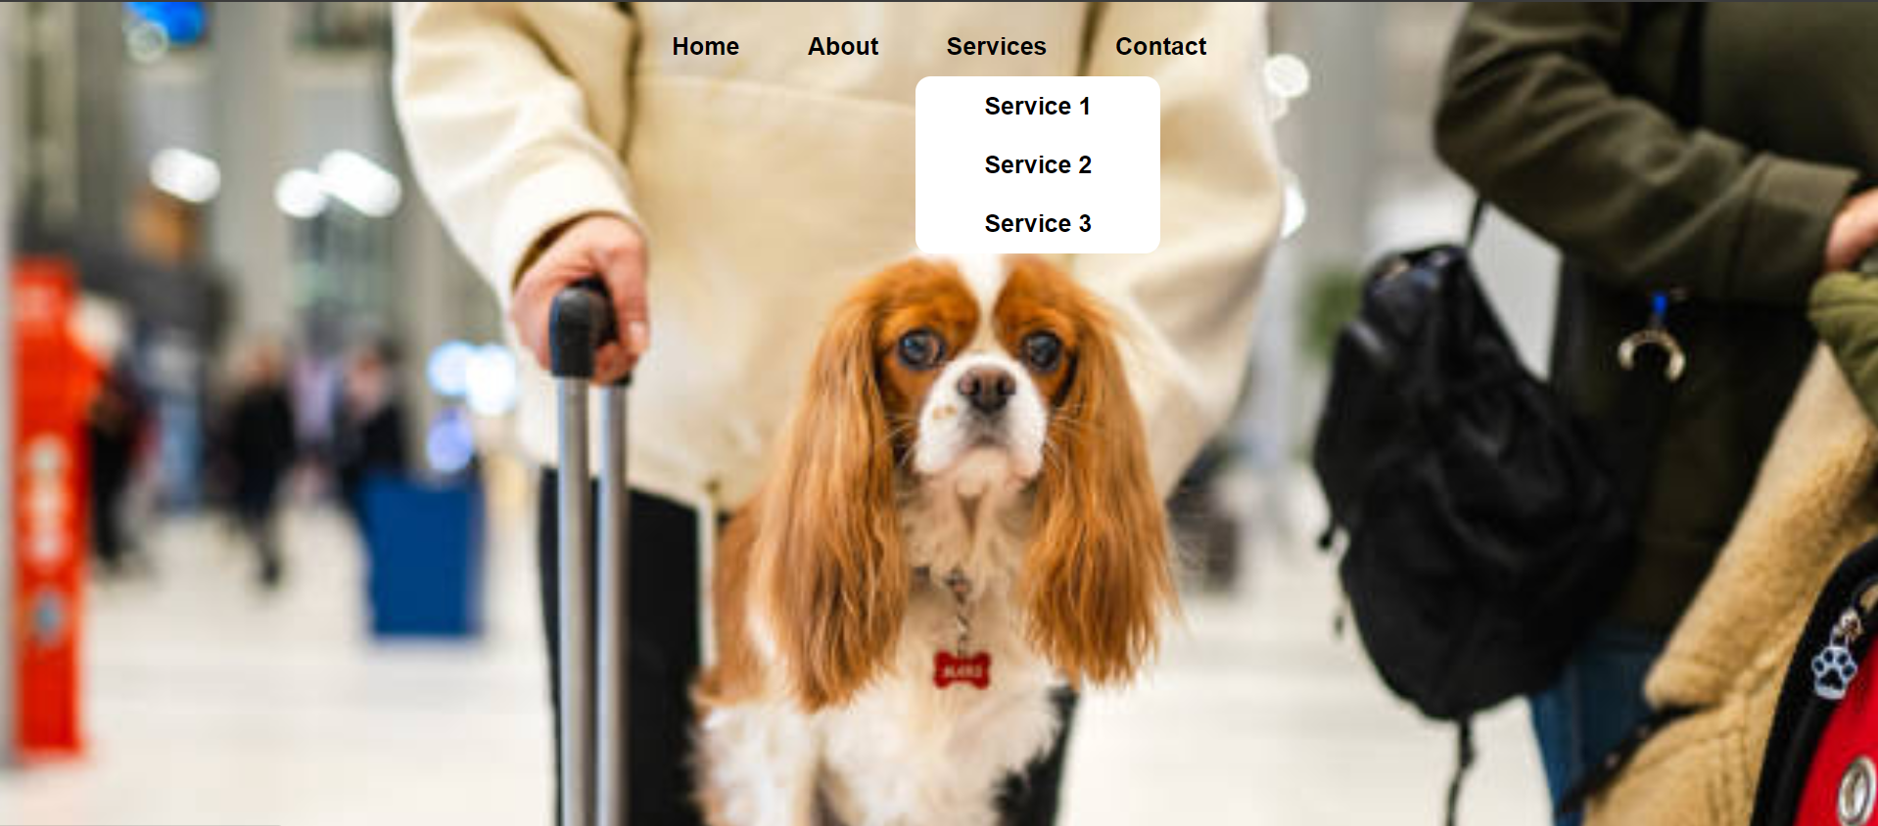

Q6: Write a JavaScript program that generates a multiplication table for a given number using for a loop .

The html code for defining structure of a web page is as follow

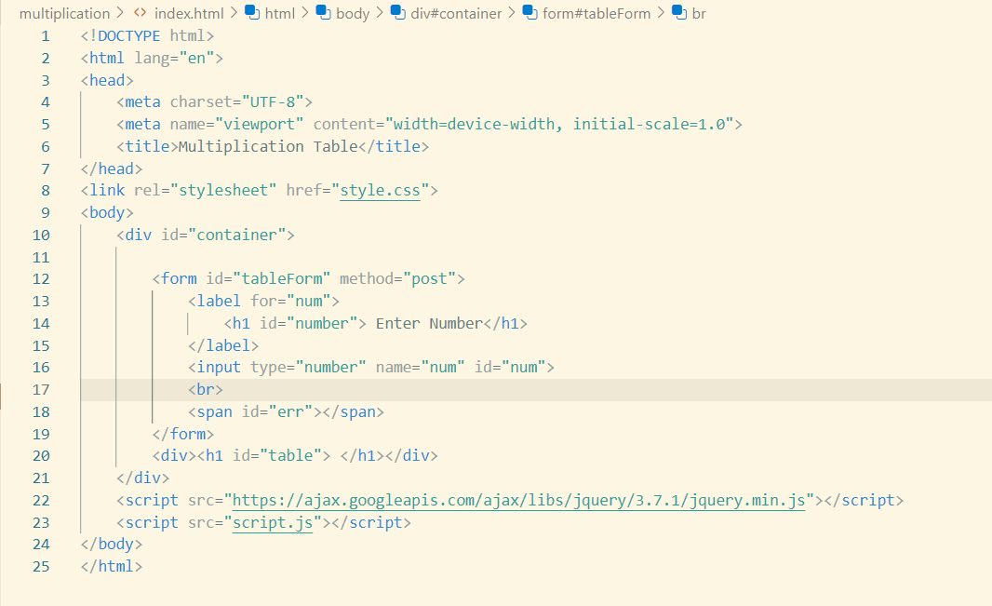

The logic behind creating multiplication table for a number using for a loop .

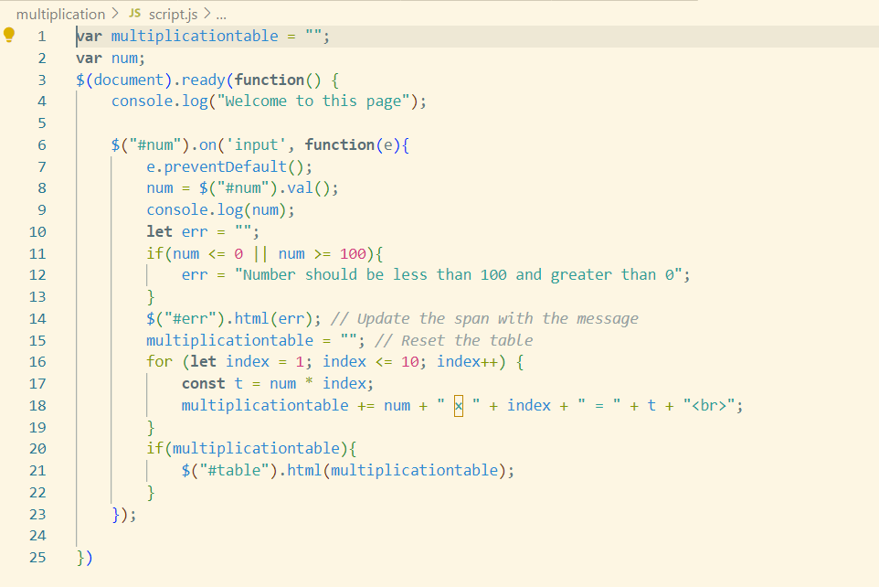

Styling of multiplication table :

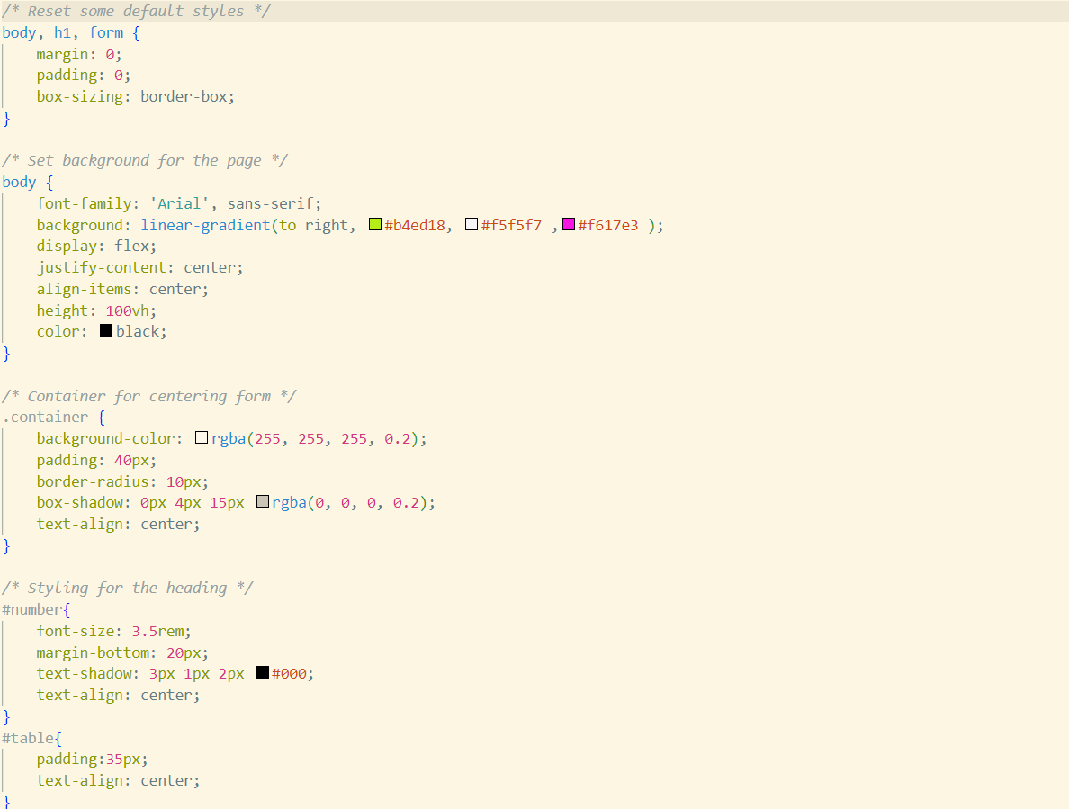 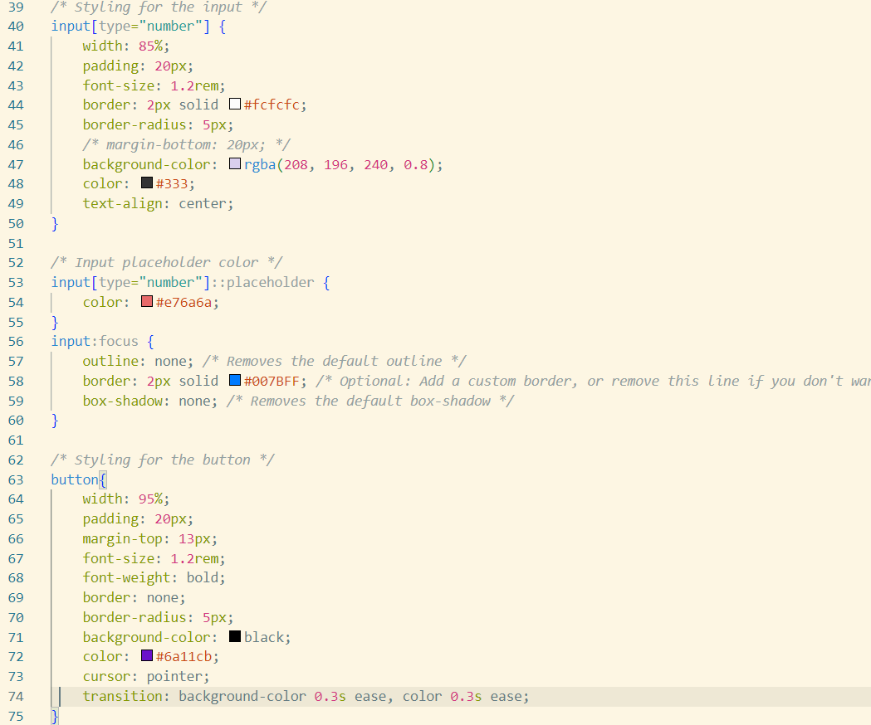

Figure Figure

­­­Output web page is as follow :

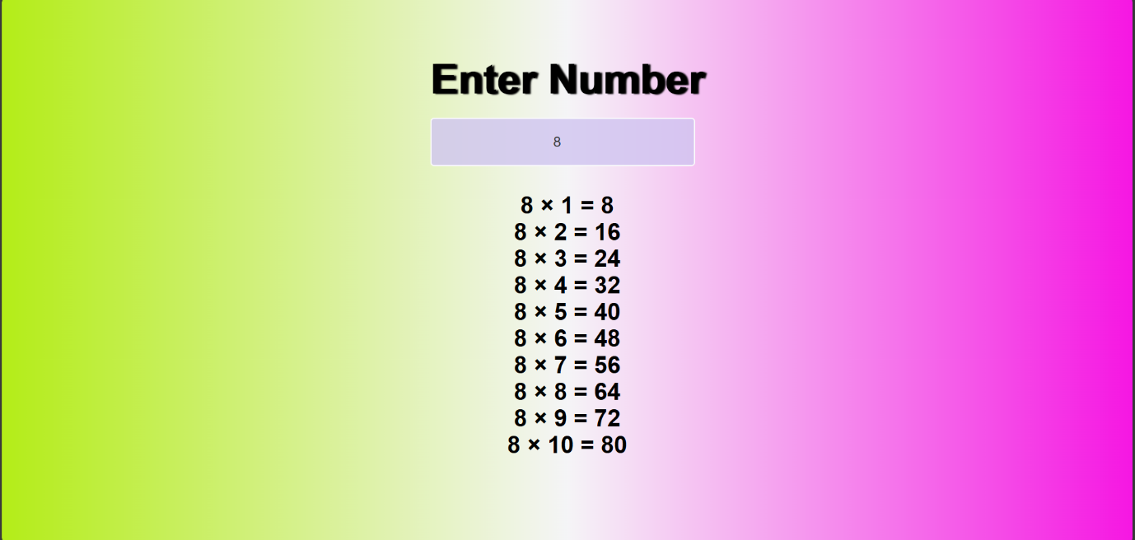

Q7 : Develop a JavaScript program that prompts the user to enter a day of the week and display a message based on the day using a switch statement .

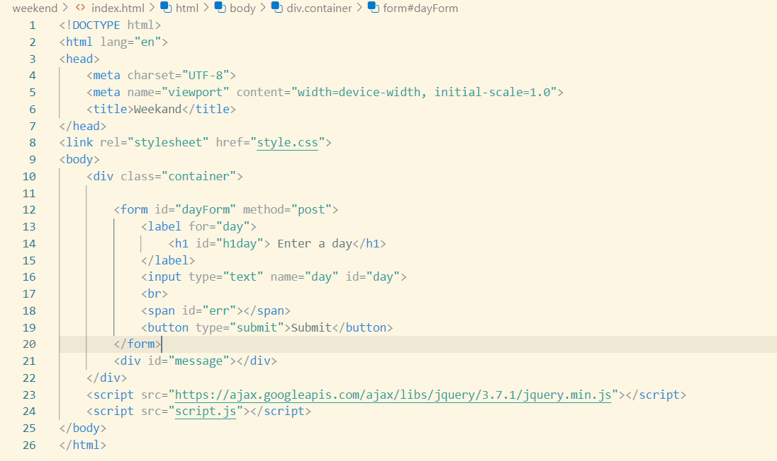

Styling of weekend html document :

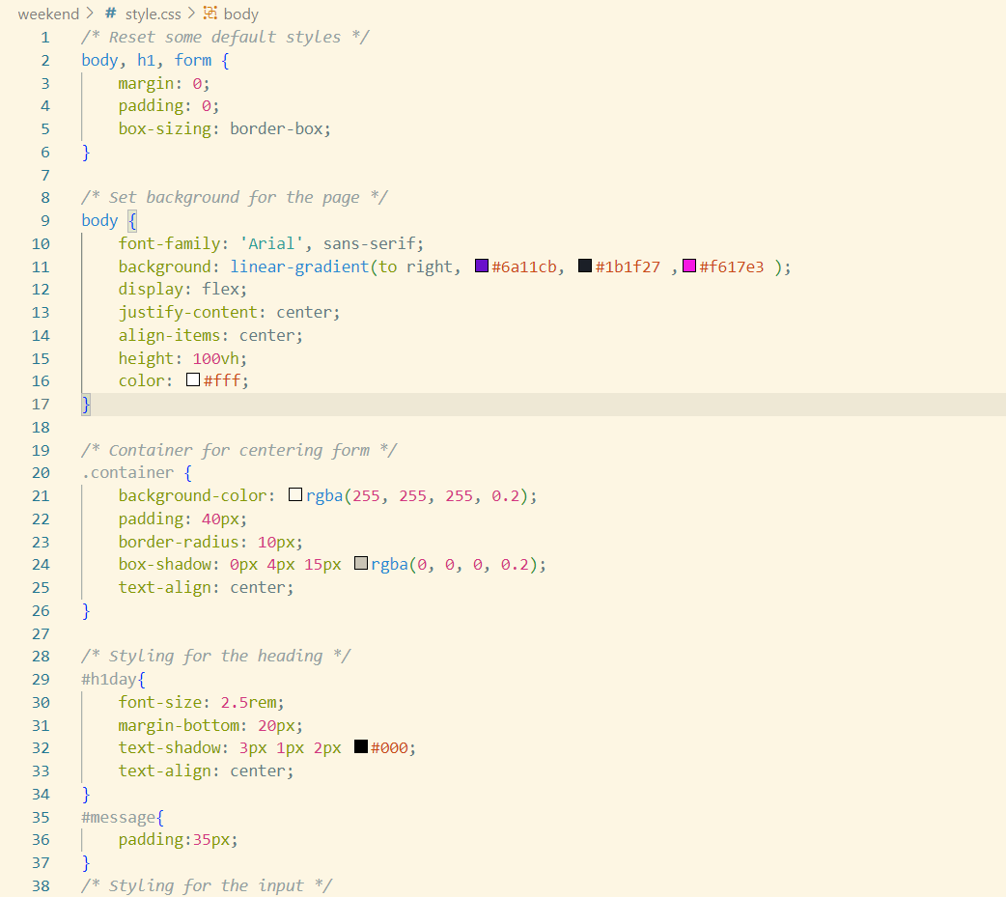

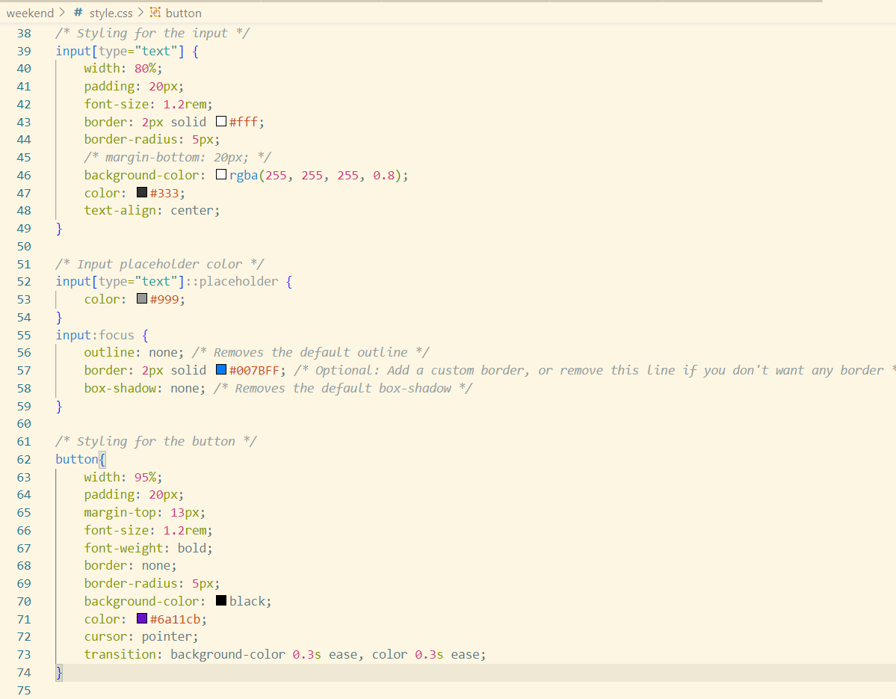

The logic of weekend program :

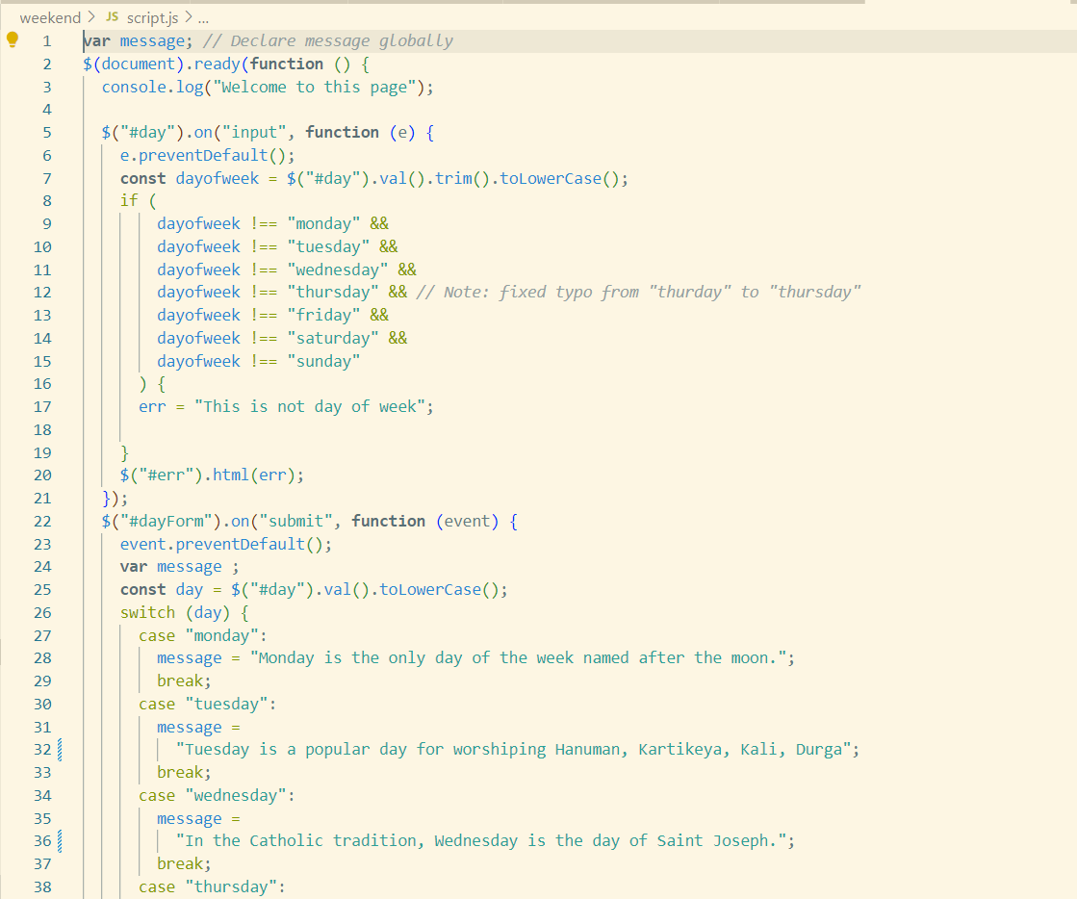

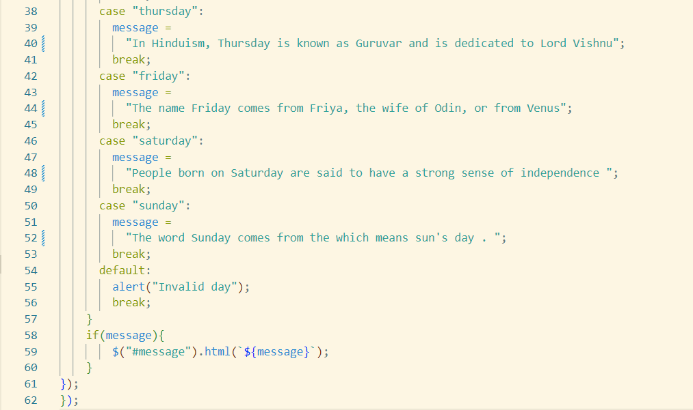

The output of weekend program is as follow :

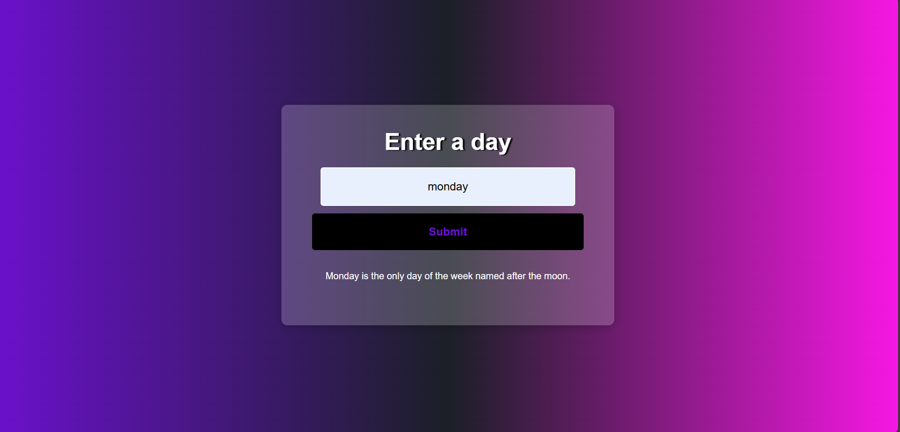

Q9. Create a Registration Form using HTML and CSS and apply the form validations using jQuery on submission event of form .

The html for Registration form is as follow :

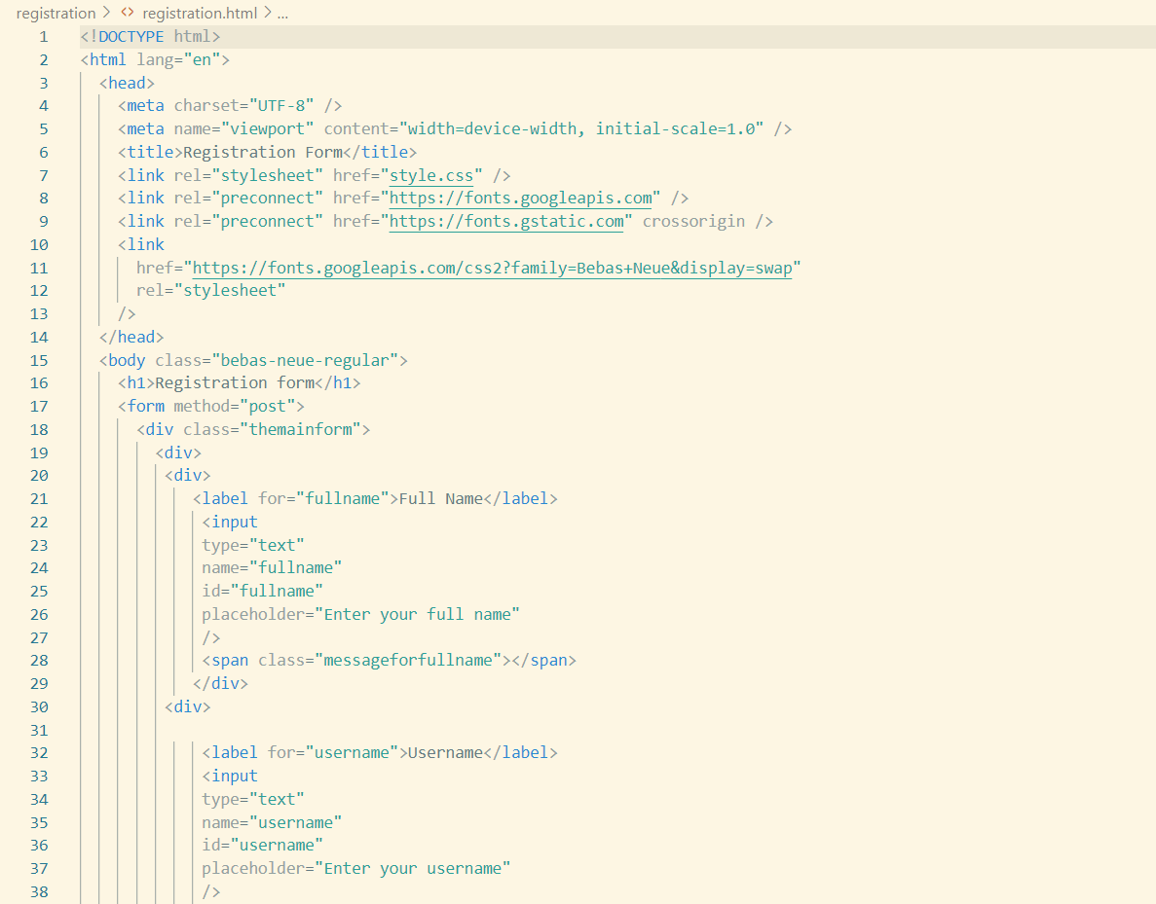

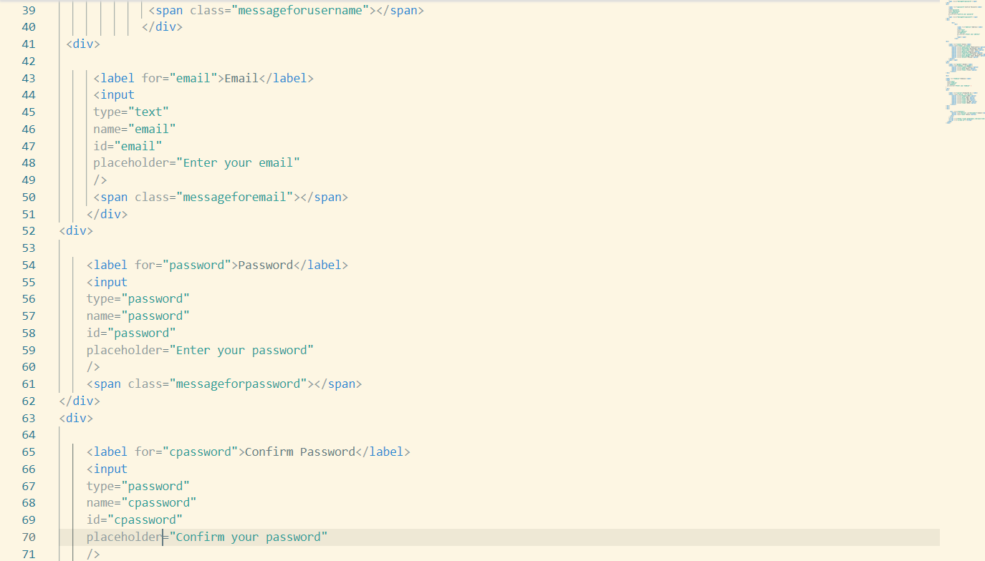

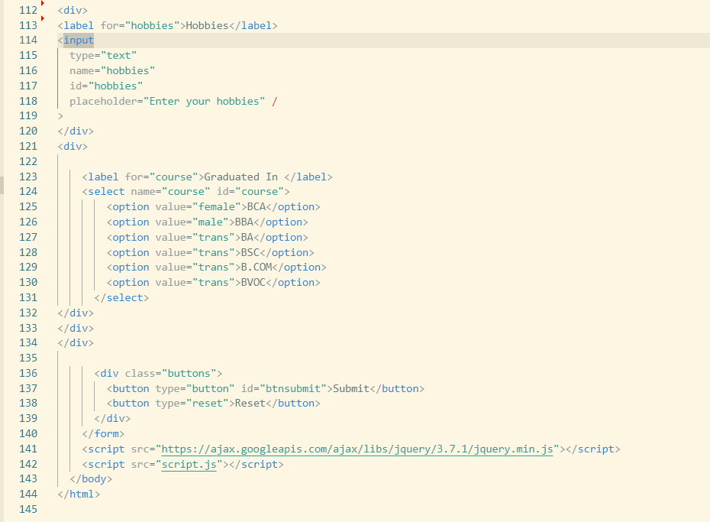

The output of this program is as follow :

